David Jan-Liu

PS#2 – Programming Questions

1. **Descriptive Statistics**

* GDP per worker in 1985 and 2005, by country

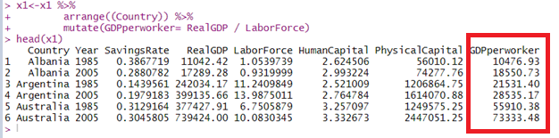

* Average Savings Rate from 1985 to 2005 by Country

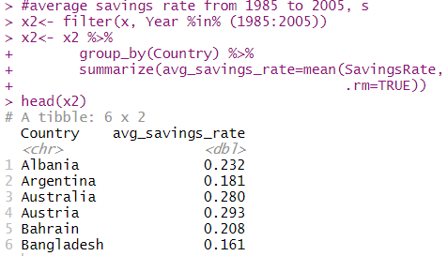

* Average Growth Rate of the Labor Force (n) from 1985 to 2005 by Country. Taking the (logt+1 – logt)*1/20, since averaging across 20 years (1985 to 2005) for each country

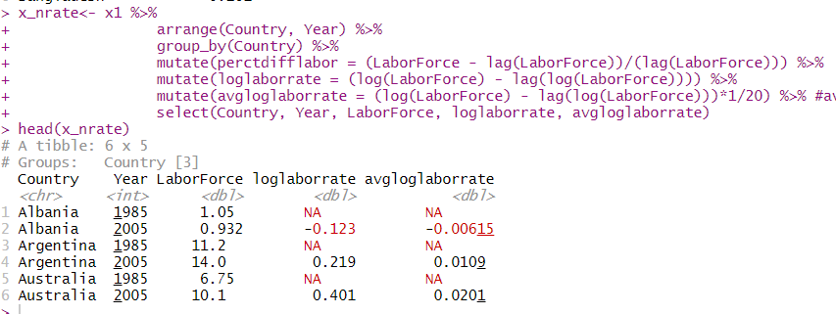

* + I added “loglaborrate”, which is (log(LaborForce)2000  - log(LaborForce)1985) and “avgloglaborrate” is loglaborrate *1/20, since we’re averaging across 20 years, looking at each average percentage growth in LaborForce by country.
* Average Growth Rate of GDP per worker from 1985 to 2005, gY/L­­.
* 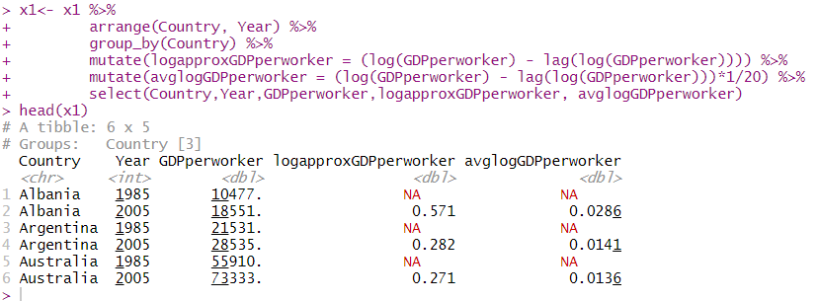

avglogGDPperworker = (log(GDPperworker)2005 – log(GDPperworker)1985)* 1/20 for country i

* Number of Countries
* 
* Mean of log(Y/L1985) across all countries at t=1985

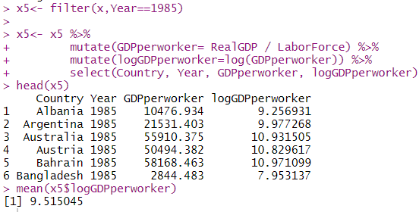

* + Showed logGDP per worker by country for 1985, then took a mean of logGDPperworker for all countries, which is 9.515
* Mean of log(Y/L2005) across all countries at t=2005

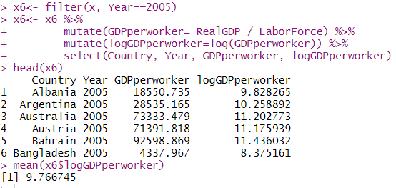

* + The mean of the log(Y/L) for all countries in 2005 was 9.766
* Mean of “s” across all countries across all time in the data set

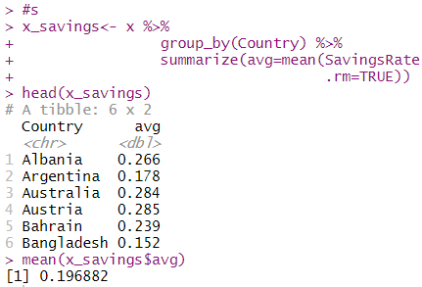

* + The average savings rate for all countries is 19.688%
* Mean of “n” (avg growth rate of labor force) across all countries across all time in the data set

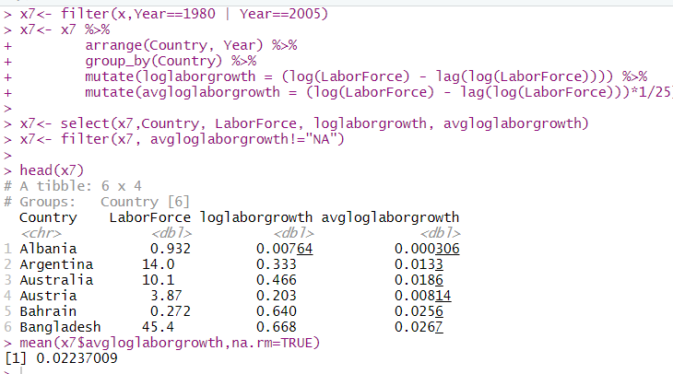

* + For each country the earliest year is 1980 and the latest year is 2005, that is a 25 year difference. So the log average growth rate of the labor force of each country, I took the (log(LaborForce)2005 – log(LaborForce)1980)1/25. So as an average for all countries, the average growth rate of the labor force per year from 1980 to 2005 is 2.237%.
* Mean of gY/L (avg growth rate of GDP/worker) across all countries across all time in the data set
* 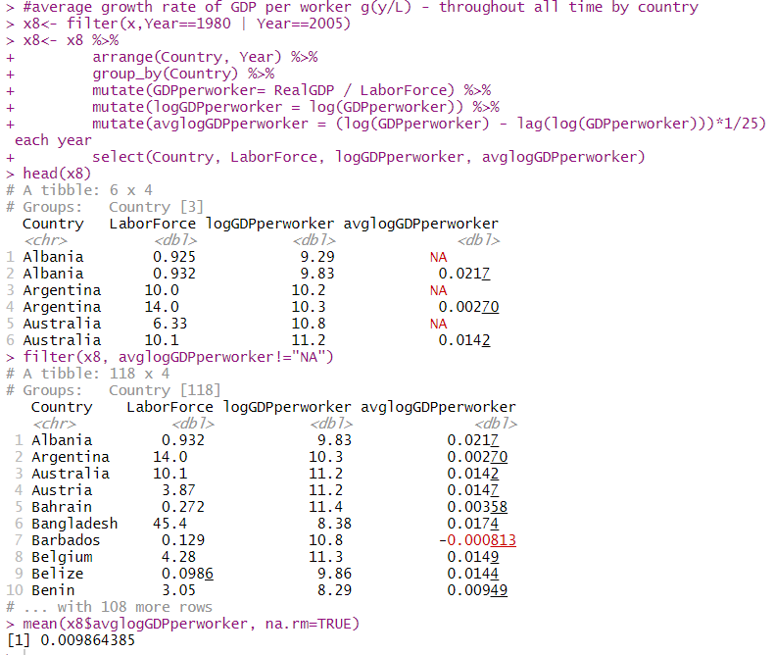
  + The average growth rate for all countries is less than 1%
* Standard Deviation across countries for Y/L1985 and Y/L2005, respectively

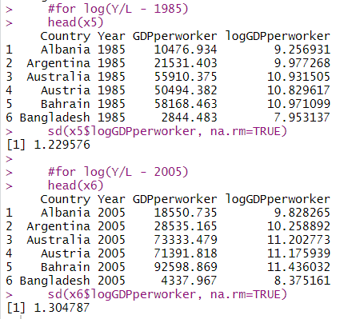

* Standard Deviation across countries & all time for “s”, the average savings rate

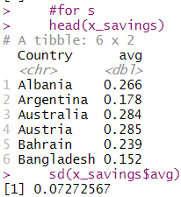

* Standard Deviation across countries & all time for “n”, the average growth rate of the labor force

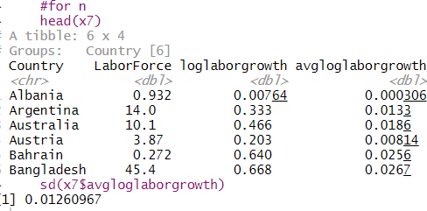

* Standard Deviation across countries & all time for “gY/L”, the average growth rate of Y/L

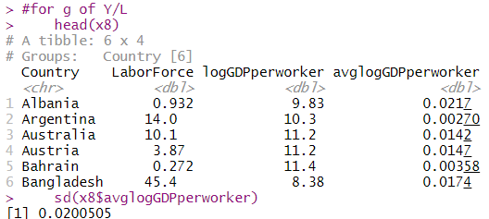

**(b)Unconditional Convergence**

Log(Y/L**1985**) on x axis and g­Y/L on the vertical axis

Preparation code for running the regression



**Regression Results**

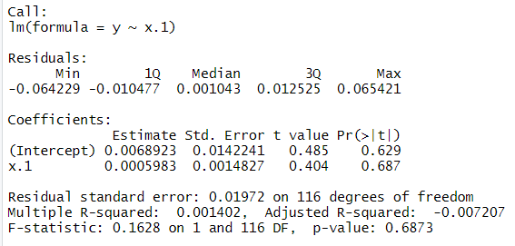

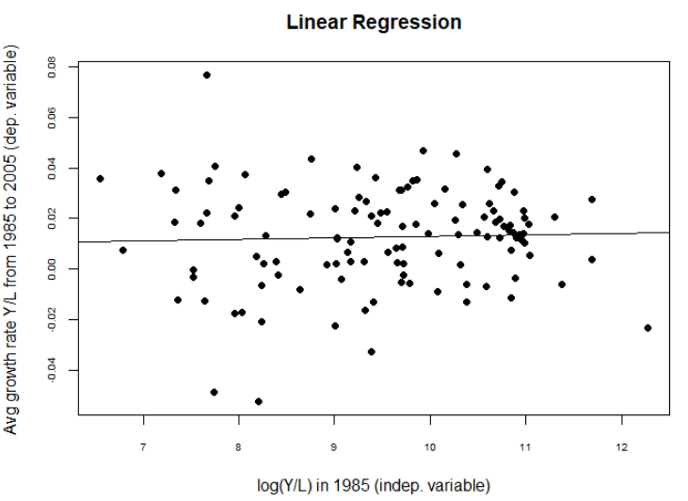

Note: I did not multiply out any rates by 100%, I kept them as decimals throughout

* + The coefficient B1 estimator is .0005983, which means the model predicts for a .01% increase in Y/L in 1985, there is a .0005983 increase in GY/L, also given that the R2 is extremely small, very little variation in log(Y/L)1985 explains the variation in the growth rate of Y/L.
  + Because this is unconditional convergence, meaning that each country follows its own steady state path and are not on the same trajectory given they have different parameters. This means that each country would not converge in the long run. Additionally, in the unconditional convergence model, having a low GDP/Capita initially does not show faster growth, so the poorer nations would not be able to catch up to the wealthier ones. It’s difficult to say whether the model predicts anything because the R2 is so low and the coefficient barely explains any change in the growth rate. Most likely the nations should remain relative to the wealthier nations.

**c) MRW Revisited**

Code setting up the multiple linear regression



Code running the multiple linear regression

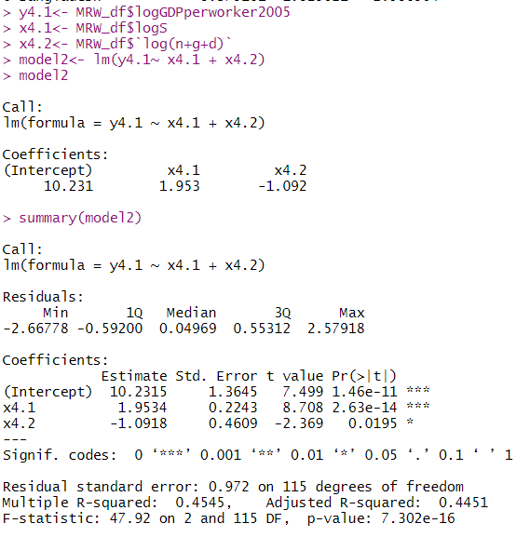

* The est. coefficient of β1 is 1.9534, thus the MLR Log-Log model shows that 1% increase in savings, predicts a 1.95% increase in Y/L2005. This suggests that living standards in nations which save more are higher, given that this is a causal model(other factors are accounted for). Also we know that Y/L is y * A, and savings drives y, which in turns drives Y/L.
* If α (the capital elasticity) should be similar to the β1 and labor share is approx. 1- α = 2/3, then α should be around 1/3 or 33% and β1 should imply a 33% increase in Y/L. I found a coefficient of 1.9534, or 1.9534% increase in Y/L, this may not be consistent with a labor share of around 2/3 because of a poor fit or low R2 that only predicts about 50% of the variation in the dependent variable from the variation in the independent variables
* The R2 = 47.46%. About half of the variation in Y/L is explained by the variation in the independent variables.

**(d) HJ Levels Accounting**

* Compute the implied value of productivity A2005 I for all countries

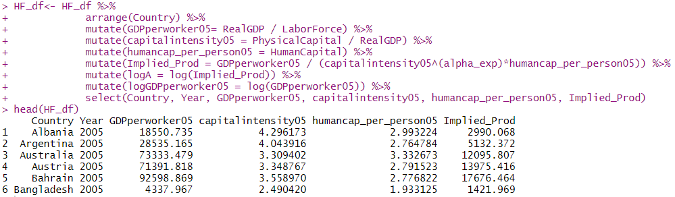

* Mean and standard deviation across countries of log (A) in 2005

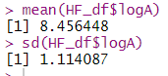

* Plot the points and regression

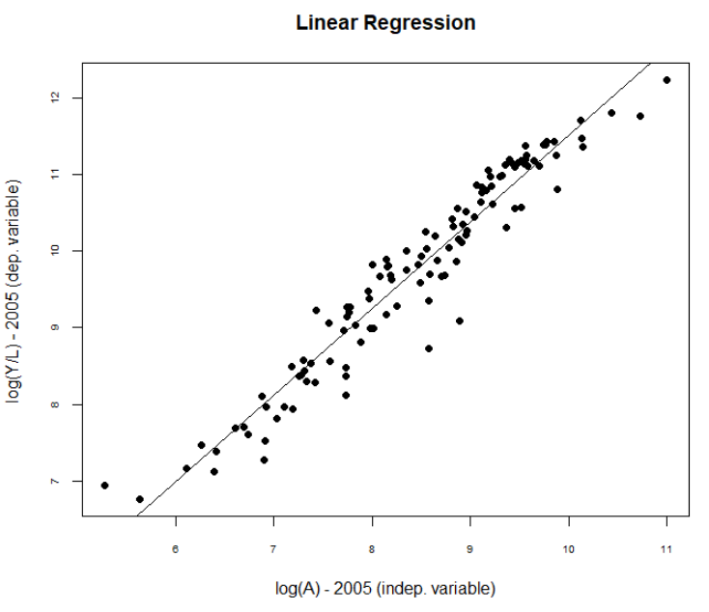

* Regress log(Y/L)2005 on log(A)2005

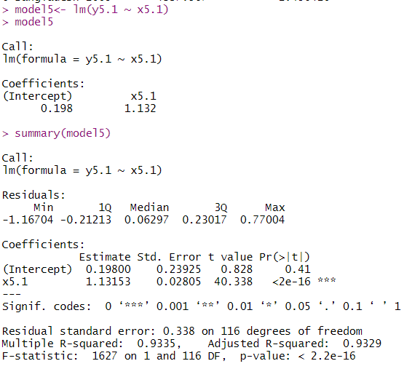

* + **Report the value of the estimated coefficient -** In this log-log model, B1 estimator is 1.1315, which is interpreted as a 1% increase in A2005 predicts a 113% increase in Y/L2005
  + **Does the estimated value of B1 suggest that living standards are higher or lower in nations with higher productivity?** Since B1 estimator is positive, it suggests that higher A predicts higher Y/L
  + **R2?** , this is interpreted as 93.35% of the variation in Y/L is explained by variation in A

Reference code for the regression:

